**Software Engineering Assignment**

**MODULE: 1 SE – Overview of IT Industry**

**Que 1. What is software? What is software engineering?**

* **Software :**
* Software is a set of instruction, data or programs used to operate computers and execute specific tasks.
* It is the opposite of hardware, which describes the physical aspects of computer. Software is a generic term used to refer to applications, scripts and programs that run on a device.
* The two main categories of software are application software and system software. Application software is software that fulfils a specific need or performs tasks. System software is designed to run a computer’s hardware and provides a platform for applications to run on top of.
* **Software Engineering :**
* Software engineering is defined as a process of analyzing user requirements and then designing, building and testing software application which will satisfy those requirements.
* Software engineering provides a standard procedure to design and develop software.
* Software Engineering is an engineering branch related to the evolution of software product using well defined scientific principles, techniques, and procedures. The result of software engineering is an effective and reliable software product.

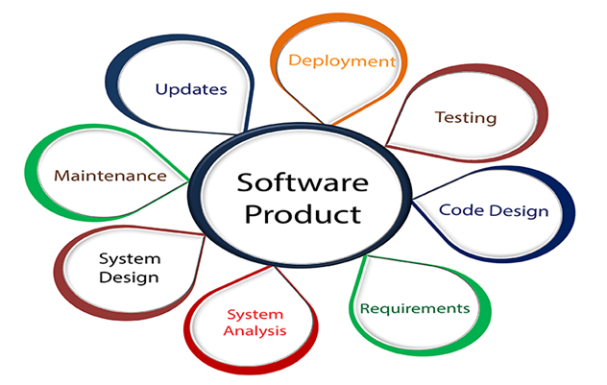

**Que 2. Explain types of software.**

* **Application Software:**
* Application software is a type of computer program that performs a specific personal, educational, and business function. Each application is designed to assist end-users in accomplishing a variety of tasks, which may be related to productivity, creativity, or communication.
* They're designed to help with specific tasks, simplify workflows, and improve communication across teams.
* An application can be self-contained, or it can be a group of programs that run the application for the user.
* Application Software is usually installed on the system as per the requirement of the user.
* This software is not capable of running independently, which means they need system software to work on.
* These are usually written in a high level language such as C, C++, Java...etc.
* Example: Microsoft Office, PowerPoint etc. Music Application software like Spotify. Communication Application Software like Skype, Zoom, google Meet etc.
* **System Software :**
* These software programs are designed to run a computer's Application Software and Computer Hardware.
* System software coordinates the activities and functions of the hardware and software.
* This software runs independently and works as a platform for working application software.
* System software work on the background, hence user don't directly interact with them.
* These are usually written in low level languages such as Assembly language.
* The OS is the best example of system software; it manages all the other computer programs.
* Examples of System Software are Operating systems, Compiler, Assembler, Device drivers, etc.
* **Driver Software :**
* A Driver software is a type of software program that controls a hardware device. On any computer, smartphone, tablet, different hardware components that are part of the computer and attached devices need to communicate with each other for a computer to function and work.

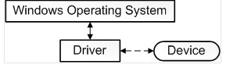

* Example: Printers Driver, Audio Driver, Video Driver, Network cards etc.
* **Middleware :**
* The term middleware describes software that mediates between application and system software or between two different kinds of application software. For example middleware enables Microsoft windows to talk to Excel and Word.
* It is also used to send a remote work request from an application in a computer that has one kind of OS, to an application in a computer with a different OS. It also enables newer applications to work with legacy ones.
* Example: Database middleware, application server middleware, message-oriented middleware, web middleware, and transaction-processing monitors.
* **Programming Software :**
* Computer programmers use programming software to write code. Programming software and programming tools enable developers to develop, write, test and debug other software programs.
* Examples of programming software include assemblers, compilers, debuggers and interpreters.
* Example : Turbo C, Eclipse, Coda, Notepad++, Sublime text.

**Que 3. What is SDLC? Explain each phase of SDLC.**

* The Software Development Life Cycle (SDLC) refers to a methodology with clearly defined processes for creating high-quality software.

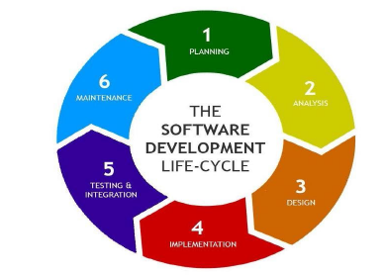

**Que 4. What is DFD? Create a DFD diagram on Flip kart.**

* DFD maps out of flow of information for any process or system. It uses defined symbols like rectangles, circles and arrows, plus short text labels to show data inputs, output, storage points and the routes between each destination.

## Symbols and Notations Used in DFDs.

|  |
| --- |
|  |
|  |

## DFD rules and tips.

* Each process should have at least one input and an output.
* Each data store should have at least one data flow in and one data flow out.
* Data stored in a system must go through a process.
* All processes in a DFD go to another process or a data store.

**Que 5. What is Flow chart? Create a flowchart to make addition of two numbers.**

* A flowchart is a diagram that depicts a process, system or computer algorithm. They are widely used in multiple fields to document, study, plan, improve and communicate often complex processes in clear, easy-to-understand diagrams.
* **Flowchart symbols :**

|  |
| --- |
|  |
|  |
|  |

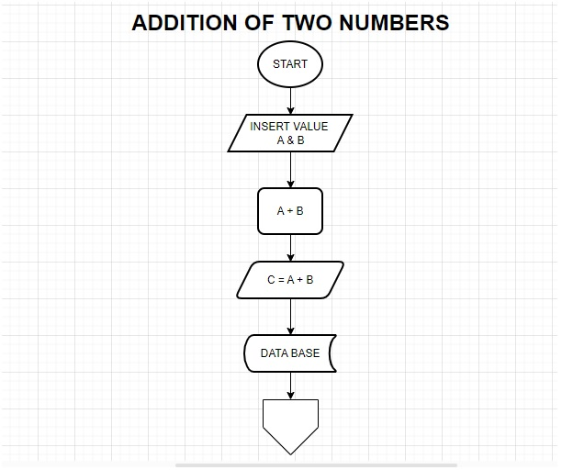

**Que 6. What is Use case Diagram? Create a use-case on bill payment on paytm.**

